User Manual of Content Management System

Homepage: The homepage contains the website title, post title, categories and it also contain the archive.

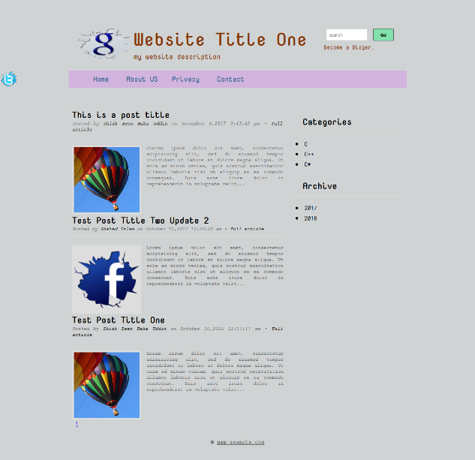

Contact: the user who can use this system must contact us when he/she faces any problem.

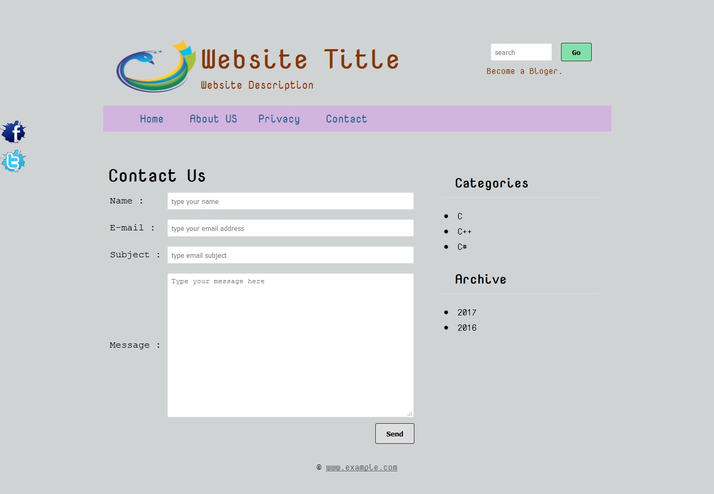

Register: the user can register the system when he/she enter our system.

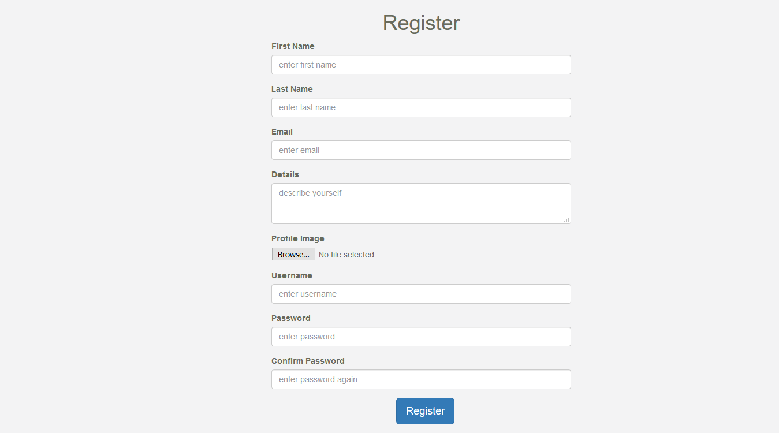

Login: The user who can enter this system at first he/she must login this system.

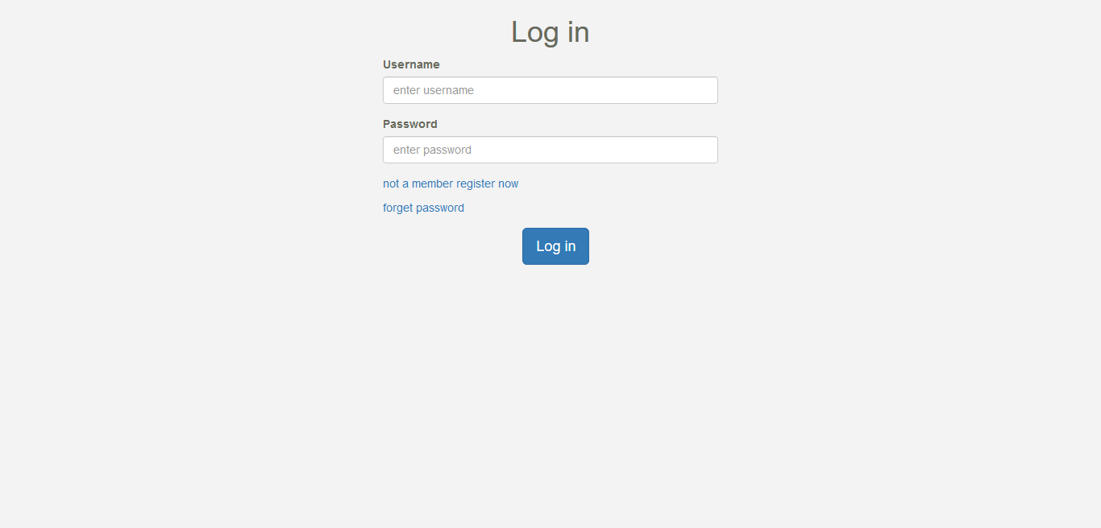

Admin Panel: the admin panel contains dashboard

appearance , manage page, manage categories, manage post ,inbox and user.

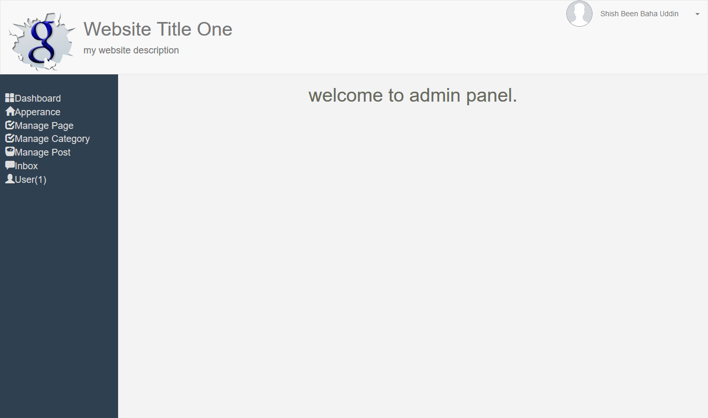

Appearance: we can add website title, website description, website logo and also we can add social media, social media theme and images.

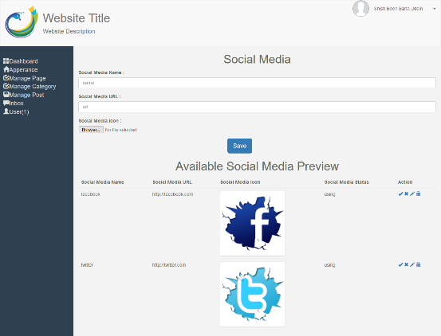 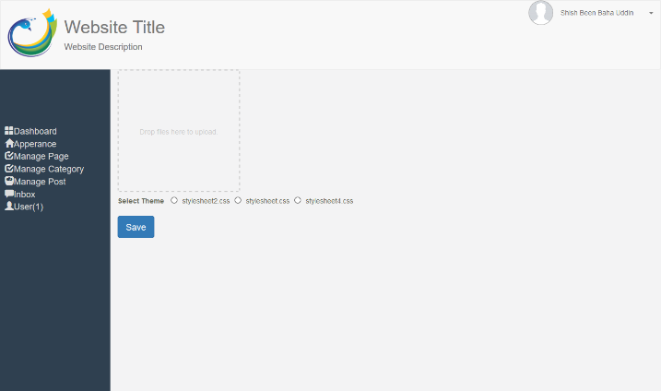

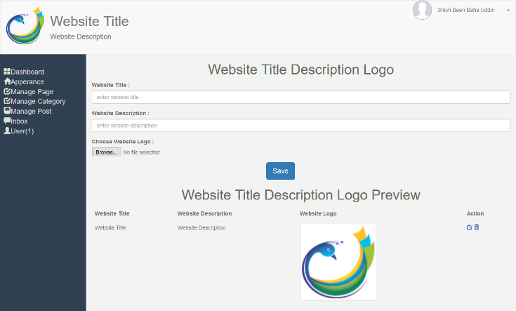

Manage page: we can add page, edit page, delete unnecessary page and view this.

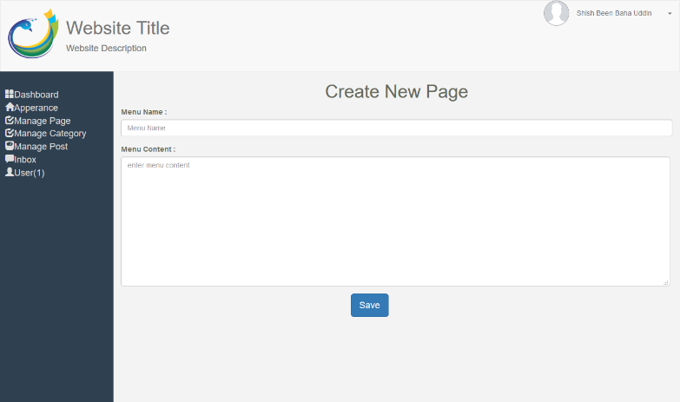 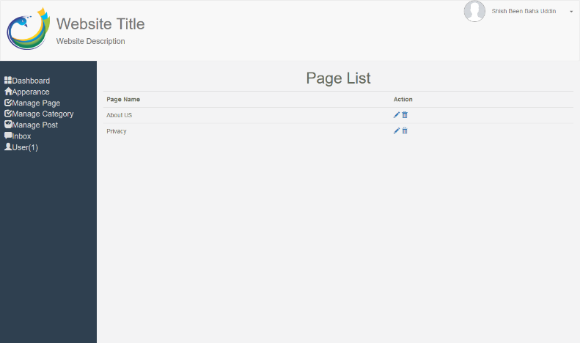

Manage categories: we can add categories, delete categories and edit this categories and finally view it.

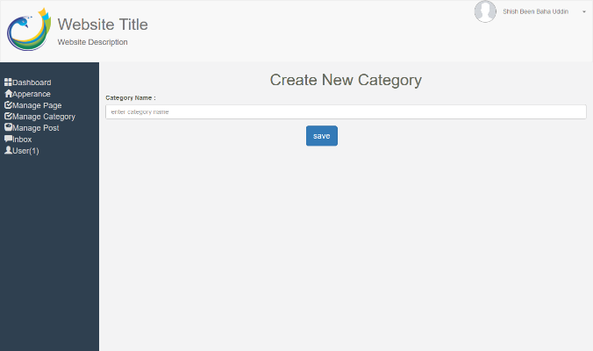 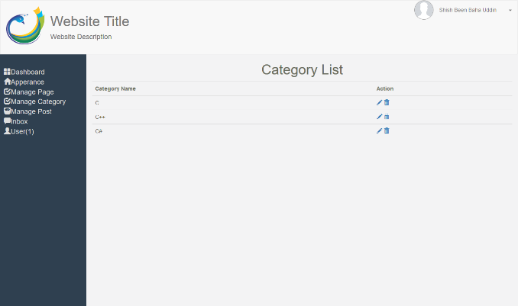

Manage post: we can create, delete and view the post.

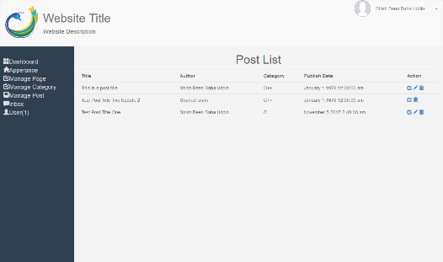 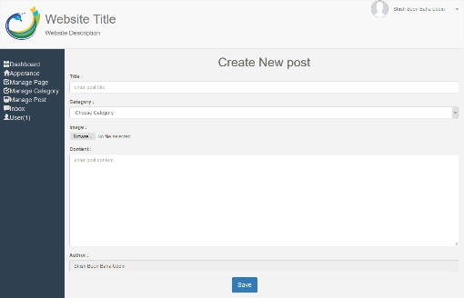

user: we can see the current user.

